Subtraction of Fractions having the Same Denominator
In subtraction of fractions having the same denominator, we just need to subtract the numerators of the fractions.
Follow the steps of subtraction of like fractions:
We can subtract in a similar way. 7/8 of the class are boys.
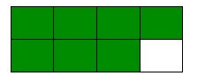
3/8 of the class are girls. By how much fraction are the boys more?
Boys 7/8

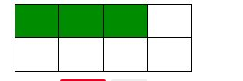
Girls 3/8

7/8 - 3/8
= (7 - 3)/8
= 4/8
EXAMPLES:
1.Subtract 5/6 from 11/6
Solution:
11/6 – 5/6
= (11 - 5)/6
= 6/6
= 1/1
= 1
2. Subtract 7/9 from 11/9
Solution:
11/9 – 7/9
= (11 - 7)/9
= 4/9
3. Subtract 4/6 from 16/6
Solution:
16/6 – 4/6
= (16 - 4)/6
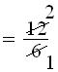
= 2/1
= 2
4. Subtract 2/4 from 17/4
Solution:
17/4 – 2/4
= (17 - 2)/4
= 15/4

